GANESH M
192524034

Experiment 4: Cloud-Based Car Booking Reservation System (SaaS)
AIM:
To create a simple cloud software application for a Car Booking Reservation System using a Cloud Service Provider to demonstrate the Software as a Service (SaaS) model.
PROCEDURE:
- Sign in to the Cloud Service Provider platform and create a new application named RideReserve Cars.
- Create the Car Booking form and add the fields: Customer name, Car model, Pickup location, Drop location, Booking date, Duration, Driver assigned, and Status.
- Configure Status as a dropdown field with predefined choices.
- Save the form and enter sample bookings to test the application.
- Verify that bookings can be searched and filtered by car model and status.
- Publish the application and access it through a web browser to demonstrate SaaS.
SCREENSHOT:
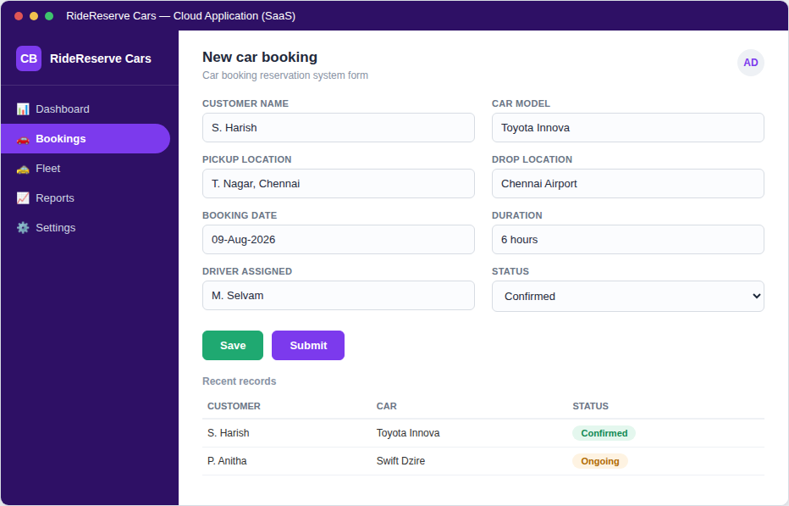

RESULT:
A cloud-based Car Booking Reservation System was successfully created. The application captured customer, vehicle, and trip details correctly and was accessible through a web browser, demonstrating the Software as a Service (SaaS) model.

